

**C PROGRAMMING**

ASSIGNMENT



 **DOON UNIVERRSITY**

**DEHRADUN, UTTARAKHAND**

**ASSIGNMENT**

**(PROBLEM SOLVING CONCEPT BAND PROGRAMMING IN C )**

**SUBMITTED TO : SUBMITTED BY :**

**MS. KAMINI BHATT PRIYANSHI BARTHWAL**

**SECTION : B**

**STUDENT ID : 25CE-59**

­­



Q.1 : PROGRAME TO PRINT “HELLO WORLD”

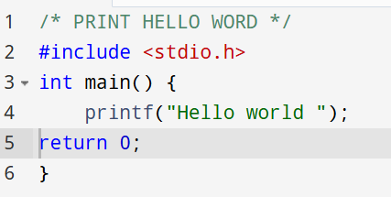

Q.2 : PROGRAM TO CHECK WHETHER A NUMBER IS EVEN OR ODD

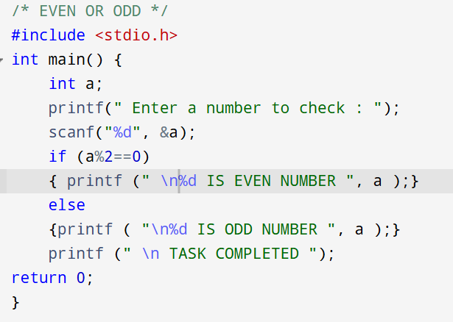

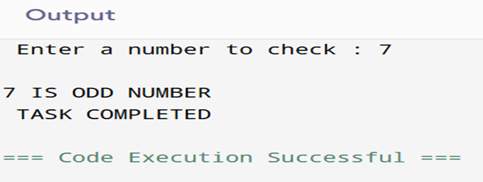

Q.3 : PROGRAM TO FIND LARGEST AMONG THREE NUMBERS

Q.4 : PROGRAME TO CHECK LEAP YEAR

Q.5 : PROGRAM USING GOTO TO REPEAT INPUT UNTIL A POSITIVE NUMBER IS ENTERED

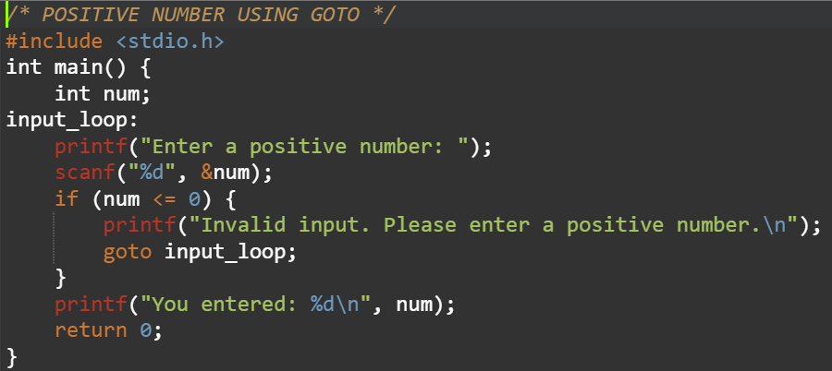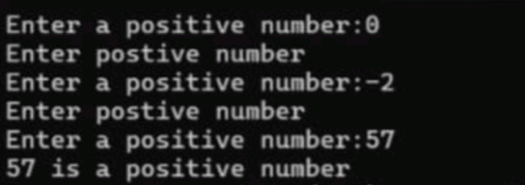

Q.6 : PROGRAM USING SWITCH CASE TO PERFORM BASIC ARTHMETI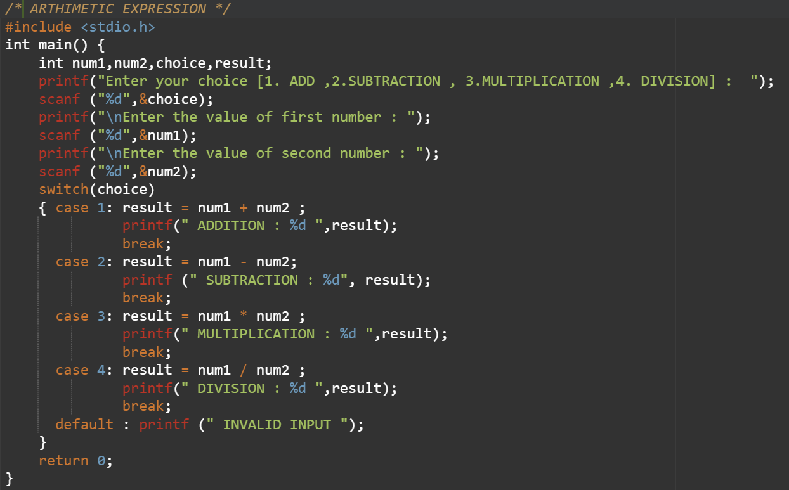

Q.7 : PROGRAM TO DISPLAY THE MULTIPLICATION TABLE USING LOOPS

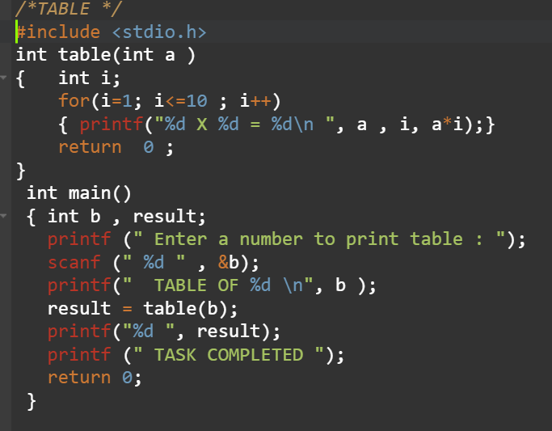

Q.8 : PROGRAM TO PRINT FACTORIAL USING WHILE LOOP

Q.9 : PROGRAM TO PRINT FIBONACCI SERIES USING FOR LOOP

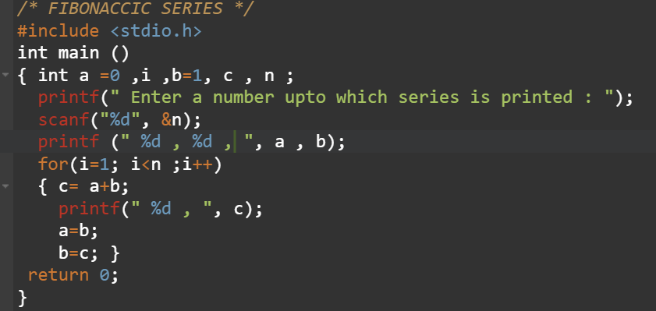

Q. 10 : PROGRAM TO FIND SUM OF DIGITS OF A NUMBER

# Q. 11 : PROGRAM TO REVERSE A NUMBER

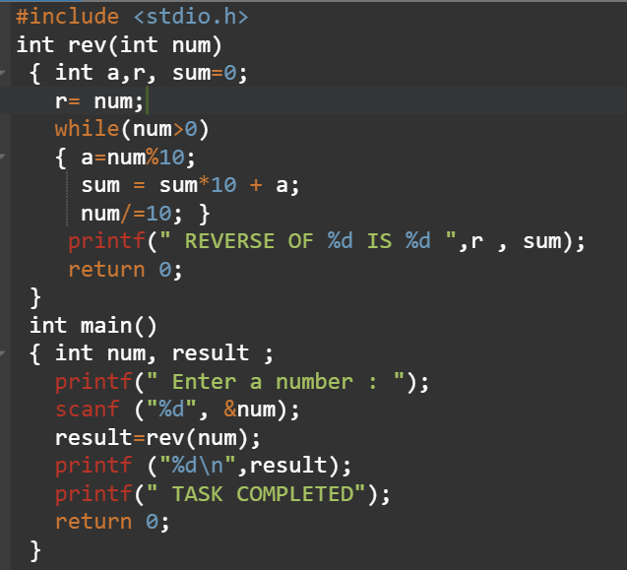

Q.12: PROGRAM TO PRINT THE FACTORIAL USING FUNCTION

Q.13 : PROGRAM TO SWAP USING CALL BY REFERENCE

Q.14 : PROGRAM TO FIND MAXIUM OF TWO NUMBERS

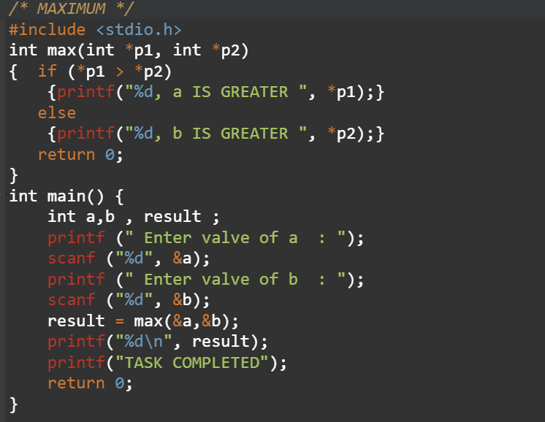

Q.15 : PROGRAM TO CHECK PRIME NUMBER

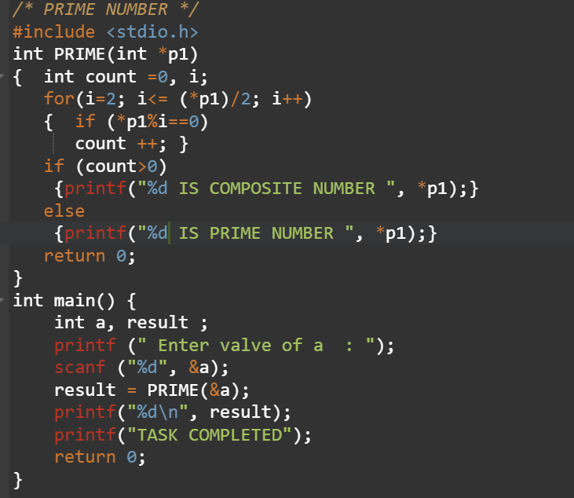

Q. 16 : PROGRAM TO CALCULATE POWER OF A NUMBER USING RECURSSION

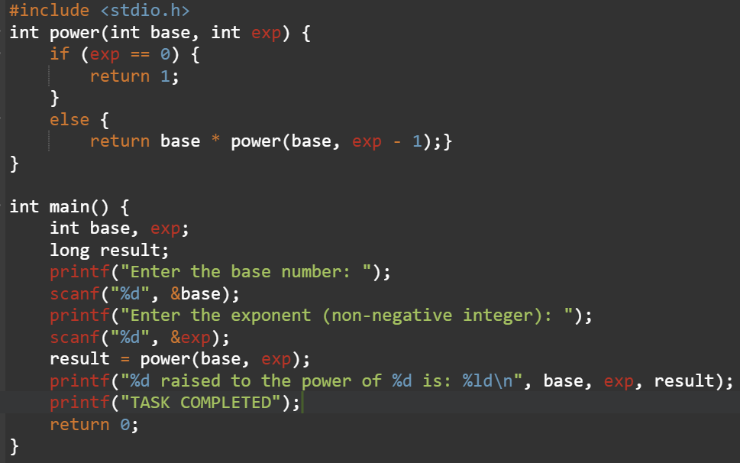

Q.17: PROGRAM TO FIND LARGEST ELEMENT IN ARRAY

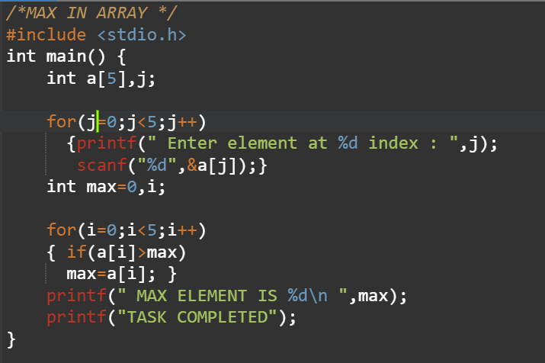

Q.18 : PROGRAM T0 CALCULATE SUM AND AVERAGE OF ARRAYS ELEMENT

Q. 19: PROGRAM TO SEARCH AN ELEMENT IN ARRAY

Q.20 : PROGRAM TO SORT ELEMENTS USING BUBBLE SORT

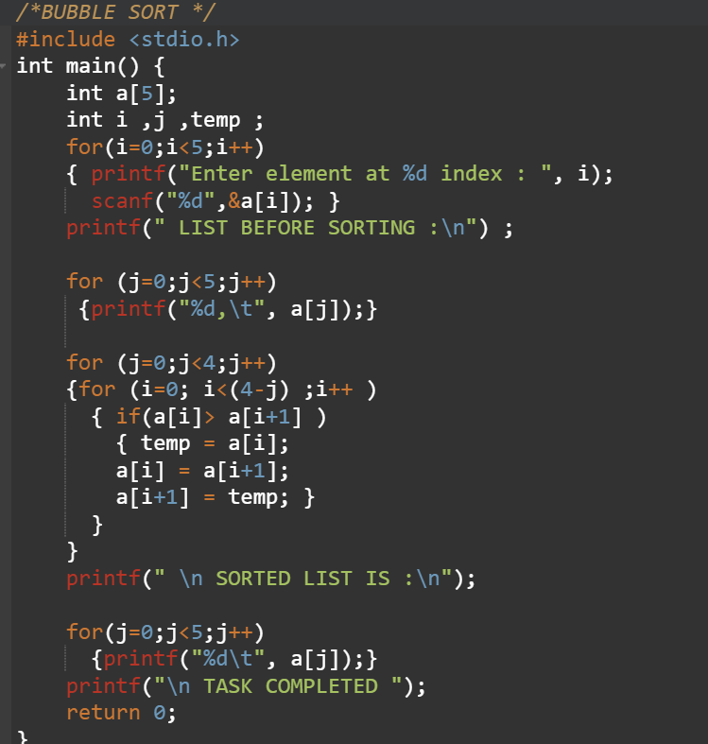

Q.21 : PROGRAM TO SEARCH ELEMENT USING BINARY SEARCH 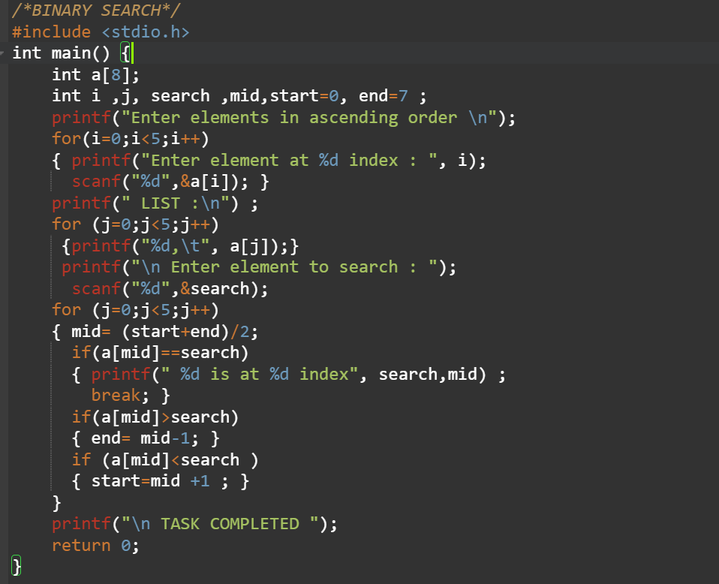

Q.22: PROGRAM TO ADD TWO MATRIX

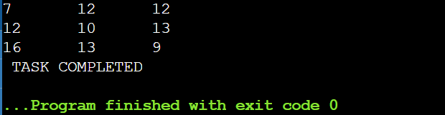

Q.23: PROGRAM TO PRINT VOWELS AND CONSONANT

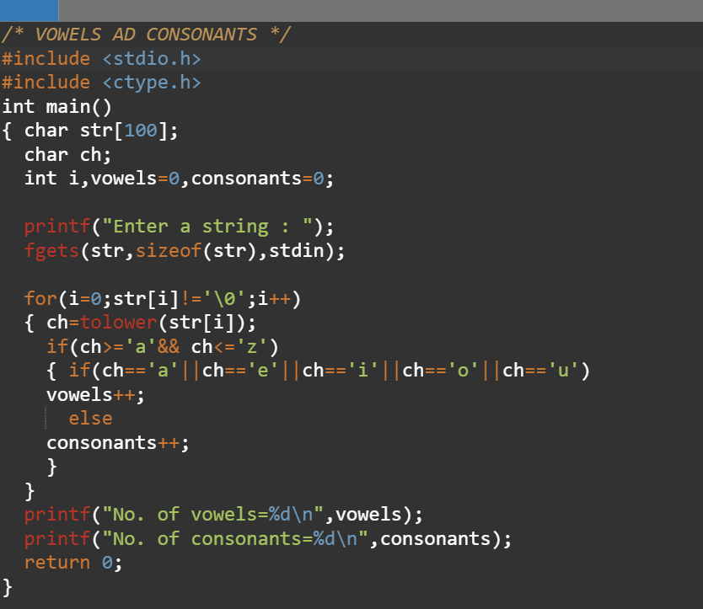

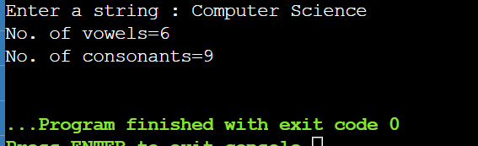

Q.24 : PROGRAM TO PRINT REVERSE OF STRING

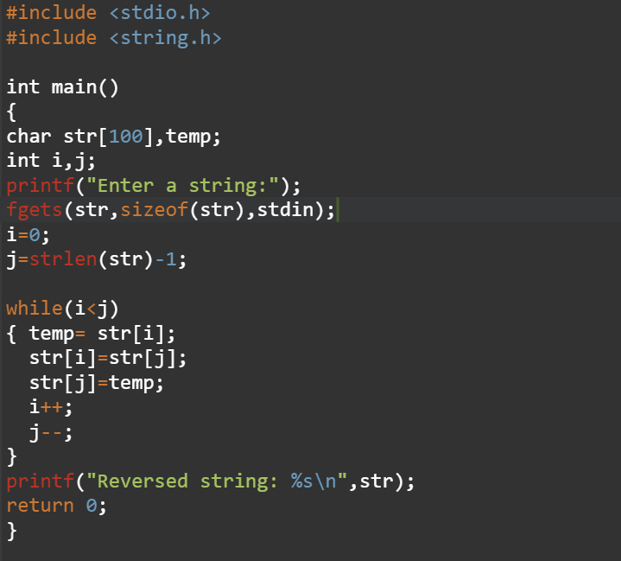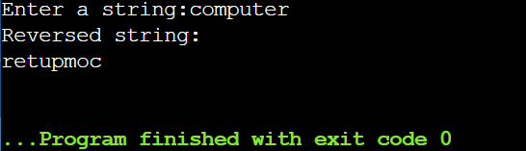

Q.25: PROGRAM TO CONCATECATE TWO STRINGS

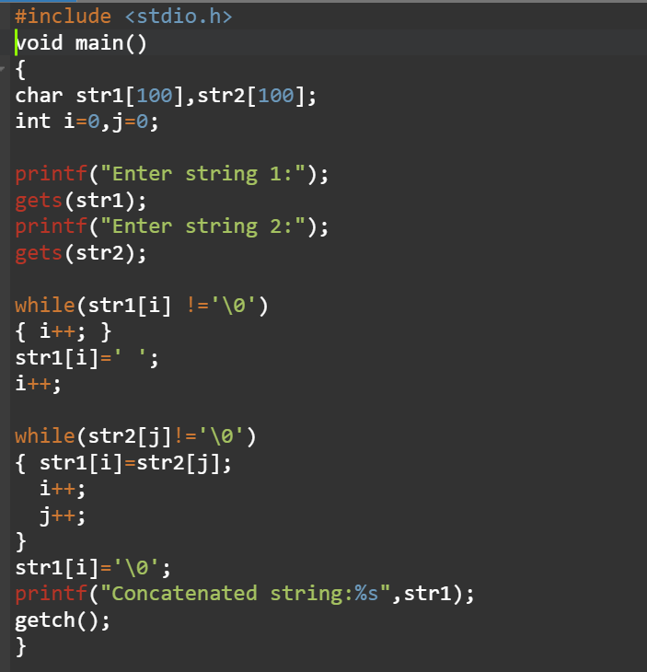

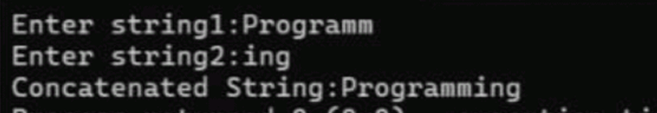

Q.26 PROGRAME TO CHECK STRING IS PALINDROME OR NOT

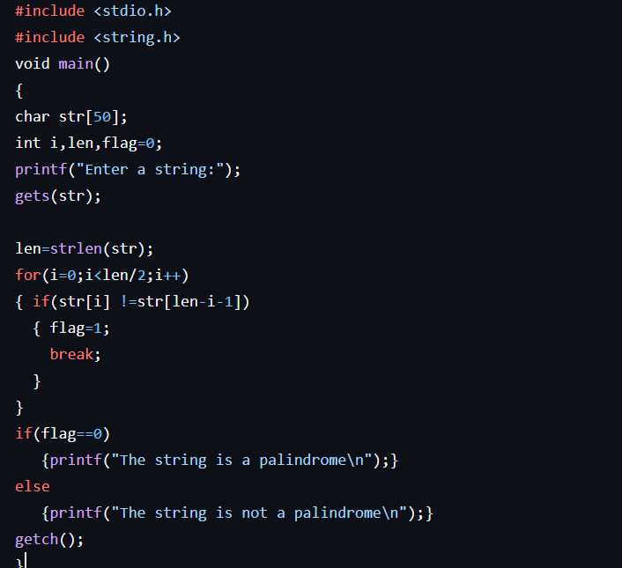



Q.27 PROGRAM USING STRUCTURE TO STORE STUDENT DISPLAY

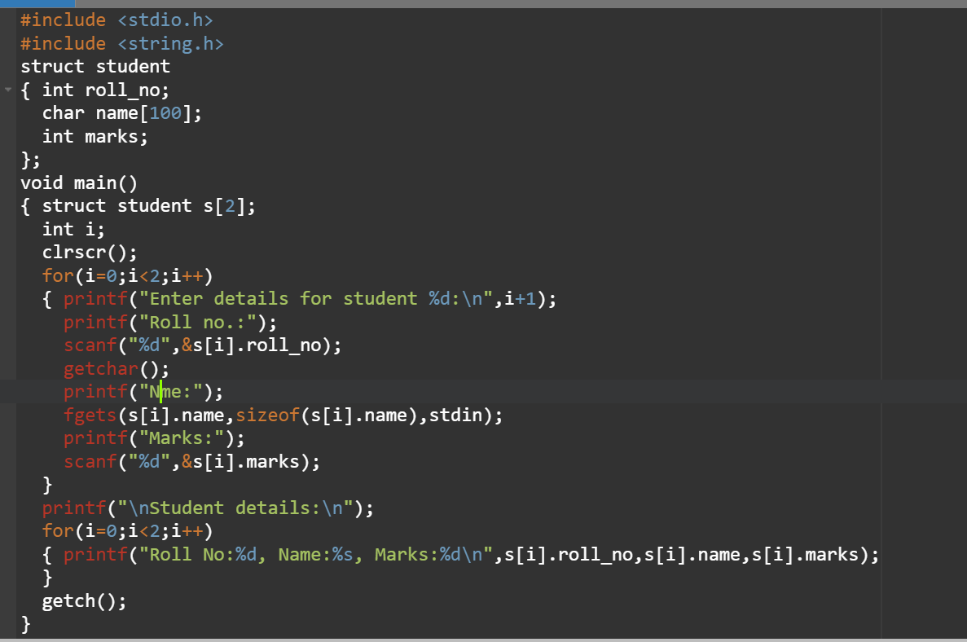

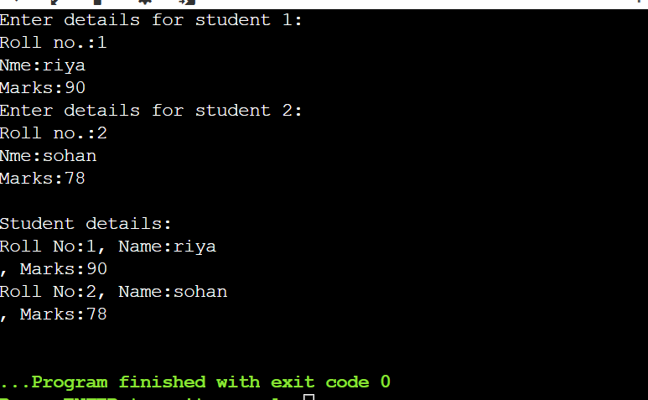

Q.28 : PROGRAM USING RECURSSION TO FIND GREATEST COMMON DIVISION

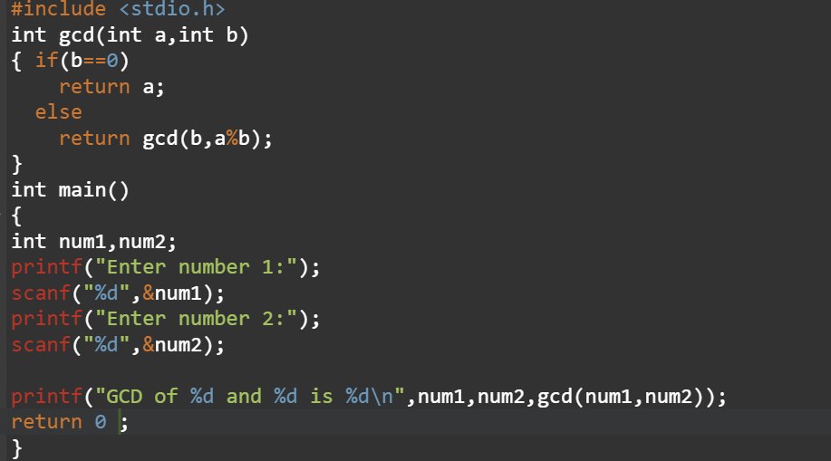

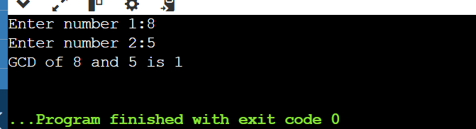

# Overhead view of hands shaking over a business papers